Clock Instructions

Most of our wall mounted clocks have either a hanging plate attached to the clock mechanism itself or a separate 'keyhole' shaped mounting plate. These are designed for the head of a screw to slot into for secure wall mounting.
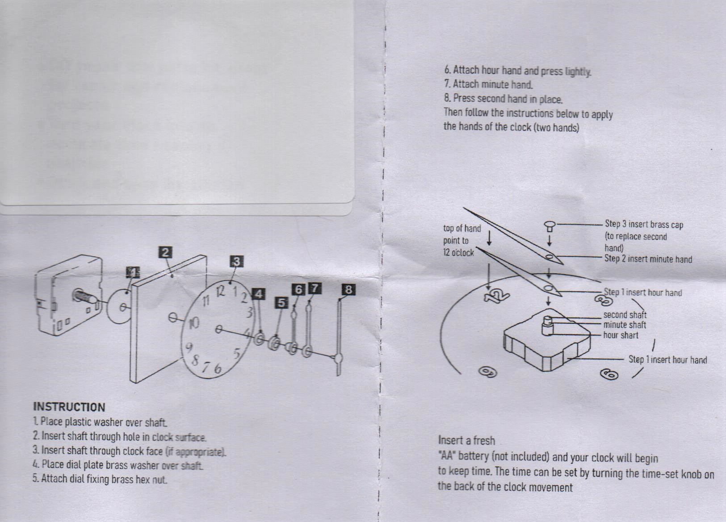
Generally clocks which we supply will already have the hands fitted, however if these have been supplied separately or if they become detached for any reason, please see the diagram above for attachment instructions. Note: the clock hands are aluminium and can be bent fairly easily. If they do appear bent they should be straightened so that they do not foul each other or rub against the clock face. They can also become sharp if damaged, please take care when handling. Do not allow objects to foul the clock hands as this can place a strain on the mechanism.

Setting the time: In order to set the time it is suggested that prior to fitting a battery the hands are all positioned at the 12 o'clock position, then use the plastic wheel on the rear of the clock mechanism to move the hands to the current time. Once the correct time is showing insert an AA type battery and the clock will begin to keep time. We normally use zinc-carbon or alkaline batteries of a reputable brand in our clocks. WE WOULD ADVISE AGAINST USING RE-CHARGEABLE or LITHIUM BATTERIES. To avoid damage please ensure that batteries are fitted with the correct polarity. If we have supplied a battery, it will be a zinc type from a recognised manufacturer.

Ensure that a suitable mounting screw/hook is used to secure your clock to the mounting surface along with a wall plug if applicable. It is recommended that clocks are not mounted where they might cause injury if they fell from their mounting (ie above a doorway). If in doubt please consult a competent trade person. Always check for the presence of pipes/electric cables prior to drilling into any wall surface.

Care is taken to ensure that wood is dried (seasoned) correctly, and that surfaces are sanded to a safe degree for handling. However, due to the nature of wood there is always the possibility of natural shrinkage, splitting, splintering, etc., particularly if items are subjected to changes in temperature or humidity. In such instances please check that item is safe for continued use, or rectify/repair prior to continuing usage.
Some products may include small parts i.e. screws, nails, clock hands, etc., and some contain glass or ceramic accessories. We advise that such items are kept away from small children and pets.

For further information please email us: info@miltoncreativecrafts.co.uk .
Clock v.1

